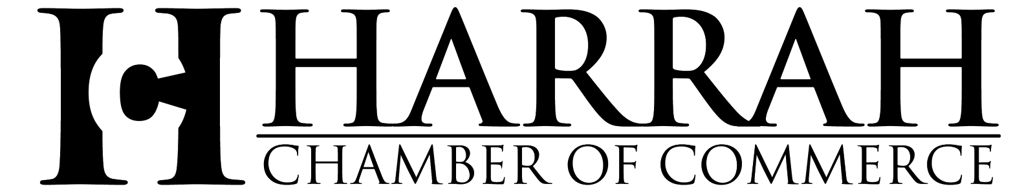
Greetings,
On behalf of the Harrah Chamber of Commerce, I would like to welcome you to our community. Harrah is an outstanding place to live, work, and grow a business. Whether you’re visiting for the day, looking for a new place to call home, or you’re already a resident of our thriving community, Harrah is a quaint little town with a big heart and plenty of opportunities. Our rich history dates back to 1898, and the Chamber was established in 1987 to advocate for and support the prosperity of Harrah and area businesses.
It is an exciting time to be a member of the Harrah Chamber of Commerce. We are always creating new networking and promotional opportunities to help our member businesses succeed and grow, including space to advertise on the Chamber website, business referrals, monthly networking opportunities, and continuing education. Other great events that allow our member businesses to gain visibility include the Annual Auction, Harrah Day Festival, and our Shop Small Saturday.
We continue to partner with local government and other organizations to pursue improvements in the overall quality of life for the city, county, and region. Our success in achieving our mission and purpose is due to a collaborative effort from the Chamber Board of Directors, City of Harrah, Chamber members, and area professionals.
Our community guide is another service the Harrah Chamber of Commerce provides to the community. We continue to work on educating residents “Where you choose to shop matters” and to encourage them to think local, be local, shop local! By supporting the businesses in our directory, you are reinvesting in your community.
To our current Chamber members, thank you for your continued support. For those of you considering relocating your business or opening a new business in Harrah, you will find that becoming a Chamber member is of great value to you. Harrah is thriveing, join us as we continue to grow.
Brandy McKay
Executive Director
Harrah Chamber of Commerce

