The Harrah Chamber of Commerce Presents
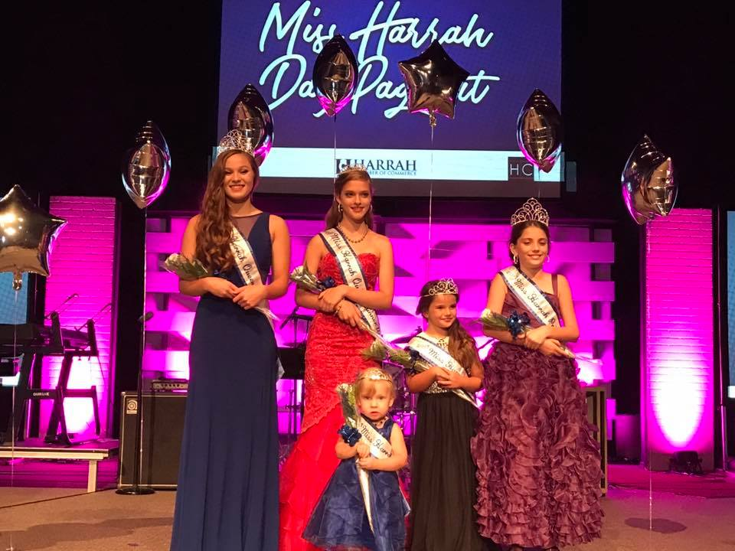
2018 Harrah Day Pageant
Saturday August 25, 2018 at 3:00pm
at Harrah Church Reno and Dobbs
Age groups for boys and girls
Tiny Tot Juniors Prince/Princess Queen/King
0-36 months 3-5 years 6-12 years 13-18 years
Application, $25 fee and head shot must be submitted by Friday July 13th, 2018

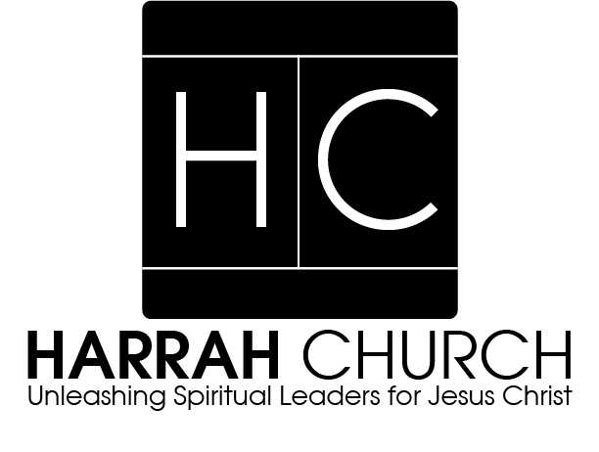
Harrah Day Registration
Name:_________________________________________________________Age:_________________
Grade:___________ School:____________________________________________________________
Parent’s Names:______________________________________________________________________
Address:____________________________________City:__________________________Zip:________
Cell Phone:___________________________Email:__________________________________________
Favorite Food:______________________________Pets:______________________________________
Candidates must reside in the Harrah School district
Age Groups
Tiny Tots-0-36 Months
Junior Prince and Princess 3-5 Years
Prince and Princess 6-12 Years
King and Queen 13-18 Years
This pageant is judges on several different criteria depending on the age group. All groups will participate in the fundraising and photo (headshot) contest. The percentages of the total score are as follows:
Tiny Tot:
Fundraising 10%, Photo (headshot) 20%, Casual Wear 30%, Party Dress/Suit 40%
Junior:
Fundraising 10%, Photo (headshot) 20%, Talent 20%, Interview 20%, Party Dress/Suit 20%
Prince/ Princess:
Fundraising 10%, Photo (headshot) 20%, Talent 20%, Interview 20%, Party Dress/Suit 20%
King/Queen:
Fundraising 10%, Photo (headshot) 20%, Talent 20%, Interview 20%, Party Dress/Suit 20%
The application, $25 fee and a digital photo must be submitted before July Friday 13th, 2018. Contestants are encouraged to place contestant jars (with the contestant’s picture) in as many locations as possible. As noted, the contestant’s fundraising efforts make up 10% of their total score. All money must be turned in to the Chamber of Commerce office (1971 Church Ave.) no later than Friday August 17th, 2018. The pageant will be held on August 25th, 2018 at 3:00pm at the Harrah Church located at 101 S. Dobbs.
Contestant are encouraged to ride in the Harrah Day Parade, however it will be the responsibility of the contest to arrange for their own transportation. The winners in each category will receive a tiara and a sash. The coronation ceremony for the public will be held on September 8th, 2018 at 4:00pm at the Harrah Heritage Park amphitheater during Harrah Day.
All monies raised through this competition help the Harrah Chamber of Commerce fund community and business projects and scholarships. All questions can be directed to Brandy McKay 405-618-1725/brandy.mckay@harrahchamber.com
Complete and send form with $25 fee and photo (headshot) to:
Harrah Day Pageant
PO Box 907 Harrah, OK 73045
Thank you to our Harrah Day Pageant Sponsors
Harrah Church and Early learning Center

